**Zip code Issue resolution**

Sample Ticket:- 270872928

1. The ticket should be validated to verify that the issue is relevant to BBW.

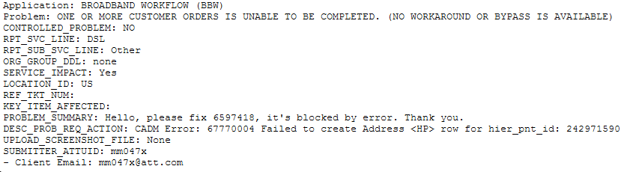

Here, Application, RPT_SVC_LINE and PROBLEM_SUMMARY fields help in determining the nature of ticket. In BBW all the relevant tickets will have their RPT_SVC_LINE as DSL. If you receive it as something else then either it is a user’s mistake or the ticket probably does not correspond to BBW, although checking once with user is advised before closing ticket just based on these factors.

There are no spreadsheets attached in this type of ticket, only Clarify case has been provided and the error message is similar to this, *“CADM Error: 67770004 Failed to create Address <HP> row for hier_pnt_id: 242971590 due to wrong Zip cd length:7834”*

The error code will always be CADM Error: 67770004 for such issues.

In BBW GUI the error code is visible in **BGate Error** tab under **Billing** tab. To access the same you need to open the BBW case 6597418 for this ticket.

Click on Billing tab

Click on BGate error tab inside, and the subsequent window will display the error if any.

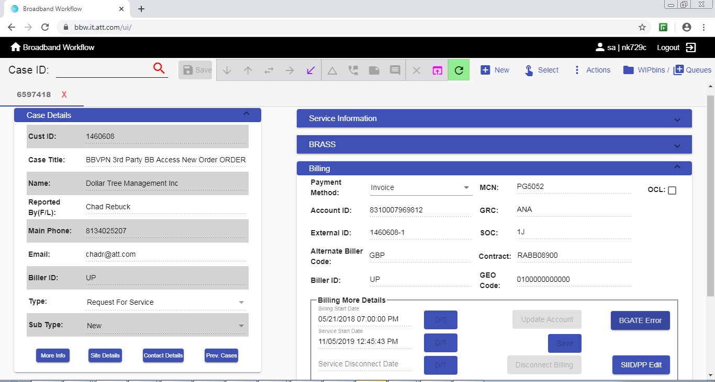

The SIID/PP Edit tab displays additional information such as access speed of the order for which it is currently being billed.

As visible from the error the zipcode is 7864 which is of incorrect length, it should comprise of 5 digits. Therefore we will need to investigate further.

1. Using the provided BBW Case ID, determine the order number of the case using the following query.

select title, id_number from table_case where id_number='6597418'



Now, select the order number from the result and determine the site ID associated with the case using the following

select site_id, order_number from table_service_point where order_number = 'CSM836457';



1. Once the site_id has been acquired, proceed to determine the current zipcode which might be causing the issue.

select site_id, cust_primaddr2address, cust_billaddr2address, cust_shipaddr2address from table_site where site_id='1181264'

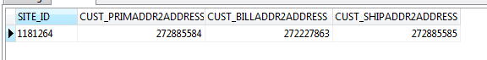

As it can be observed in the above illustration, there are 3 separate objids associated with address, they need to be checked for incorrect zipcode.

However, the incorrect zipcode is mostly present in the **cust_primaddr2address** field.

1. Using the following query identify the incorrect data field.

select address, city, state, zipcode from table_address where objid='272885584'

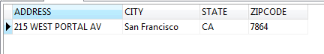

Once the incorrect field has been identified, check the correct zipcode associated with the address/city online and populate the same in the next query to update the incorrect zipcode.

UPDATE table_address SET zipcode='94127' WHERE objid='272885584';

Commit;



1. Once the required updated have been successfully completed, intimate the user.
2. User will try to resubmit the case post update.
3. After successful validation from the user, you can proceed to set the ticket to RTC state.

**NOTE** :- This is termed as a workaround and therefore development team’s or SME’s involvement is advised.